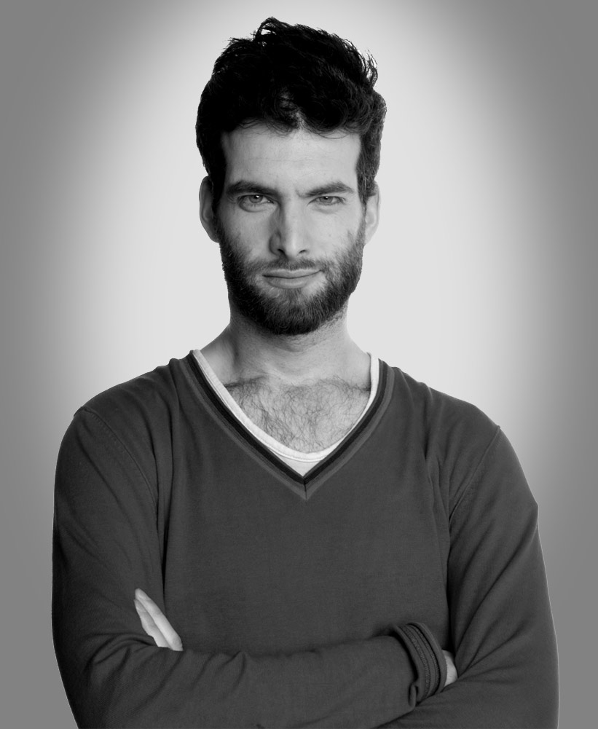

AVALON MANAGEMENT GROUP LTD
4A Exmoor Street, London W10 6BD
Phone: 020-7598 8000
Fax: 020-7598 7300
WWW: www.avalonuk.com

DAN ANTOPOLSKI

"Solid gold... one of this Festival's unequivocal highlights."
The Scotsman

"Intelligent, thoughtful stand-up ... hilarious, imaginative and wonderfully cheap."
The Independent

PERSONAL DETAILS

Location: London
Height: 185cm
Playing Age: 25-30 years
Role Types: White
Eye Colour: Blue
Hair Colour: Dark Brown
Hair Length: Mid Length

SKILLS
Accents & Dialects: (* = native)
French, RP*

Languages: (* = mother tongue)
English*, French

Music & Dance: (* = highly skilled)
Keyboards*, Saxophone*

Performance: Comedy, Compere, Radio Presenting, Stand-up Comic, TV Presenting, Voice Over

Vehicle Licences: Car

Other Skills: Acrobatics

TELEVISION

Comedy Cuts, ITV2, 2006 - 2008
Writer/Performer

Hyperdrive (Series 1 and 2), BBC Two, 2006 - 2007
‘Jeffers’

Harry Hill’s TV Burp, ITV1, 2007
Jesus

Moonmonkeys, BBC Three, 2006
Performer

28 Acts in 28 Minutes, BBC Three, 2006
Performer

AD/BC, BBC Three, 2004
‘King Herod’

Mothership, Pilot directed by Armando Iannucci, 2004
‘Jeffers’

The Live Floor Show, BBC Two, 2002 – 2003
Performer

Time Gentlemen Please, Sky One, 2002
‘Student’

The World Comedy Tour, Comedy Central 2002
Performer

Brain Candy, BBC Choice, 2002
Wrriter/Performer

The Stand-Up Show, BBC One, 1999 - 2001
Performer

Cherry Pop, UK Play, 2000
Presenter

FILM

The Da Vinci Code, 2006
‘Jesus Christ’

It’s All Gone Pete Tong, 2004
‘Eric Banning’

Big Girl Little Girl, 2004
‘Olly’

RADIO

This Is My Mark, BBC Radio 4, 2009
‘Billy’

4 Stands Up, BBC Radio 4, 2009
Performer

Out To Lunch, BBC Radio 2, 2006 - 2008
Performer

One, BBC Radio 4, 2006 - 2009
Performer

The Dan Antopolski Show, BBC Radio 2, 2007
Writer/Performer

Peacefully In Their Sleeps, BBC Radio 4, 2007
‘Colin Anderson’

Exterminating Angels, BBC Radio 4, 2007
‘Tony’

Undone, BBC Radio 4, 2006
‘Marlboro’

28 Acts In 28 Minutes, BBC Radio 4, 2006
Performer

The Dinks’ Milk Run Special, BBC Radio 1, 2005
Performer/Writer

Flight Of The Conchords, BBC Radio 4, 2005
‘Tim/Bernard’

The 99p Challenge, BBC Radio 4

LIVE

Dan Antopolski’s Penetrating Gaze, Edinburgh Festival, 2008
Solo Stand-Up Show

A Whim Away, Edinburgh Festival, 2004
Solo Stand-Up Show

The Dinks 2: Mouthbreathin’, Edinburgh Festival, 2004
Stand-Up with Craig Campbell and Tony Law

The Dinks, Edinburgh Festival, 2003
Stand-Up with Craig Campbell and Tony Law

The Presence, Melbourne International Comedy Festival, 2003
Solo Stand-Up Show

The Presence, Edinburgh Festival, 2002
Solo Stand-Up Show

Antopolski 2000, Edinburgh Festival, 2001
Solo Stand-Up Show

FHM Edinburgh and Beyond Comedy Tour, National Tour, 2000
Stand-Up with Simon Day, Lee Mack and Karen Taylor

Lee Mack’s New Bits, Edinburgh Festival, 2000
Sketch show with Lee Mack and Catherine Tate

Second Coming, Edinburgh Festival, 2000
Solo Stand-Up Show

Lee Mack’s Bits, Edinburgh Festival, 1999
Sketch show with Lee Mack and Catherine Tate

The Comedy Zone, Edinburgh Festival, 1999
Stand-Up

AWARDS

Nominated – Perrier Award for Antopolski 2000, Edinburgh Festival, 2001

Nominated – Perrier Award for Lee Mack’s New Bits, Edinburgh Festival, 2000

Nominated – Perrier Best Newcomer Award for Second Coming, Edinburgh Festival, 2000

Winner - BBC New Comedy Award, 1998

WHAT THE PRESS HAS SAID:

DAN ANTOPOLSKI’S PENETRATING GAZE

"Innovative, truth-seeking, weirdly magical stuff ... he stands in a comedy spotlight all of his own ... Satisfyingly unorthodox, intelligent and ridiculously playful. Thank heaven - with special thanks also to hell - for Dan Antopolski."
Claire Sawers, The List ****

"The work in folly of writing a six minute rap about sandwiches is a reason to be cheerful, and worth the entry price alone. Go check out Dan Antopolski mark 2; now with added life experience."
Dave Mountfield, fringereview.com ****

"His mastery of the English language is worth a Fringe show in itself."
James Murray, Three Weeks ****

"An absolute delight. It's quite right and fitting that he is partial to donning a cape; he is after all, a bit of a hero."
Ian Phillips, National Student ****

OTHER PRESS

"An intriguing hour of intellect-tickling comedy ... Disarmingly improvisational ... unashamedly educated ... the resultant laughs are lacquered with a growing admiration for his innovation, beat-for-beat timing and prophetic puppet-mastery of the crowd." Graeme Virtue, Sunday Herald *****

“Triple Perrier nominee Antopolski really does deserve to win that damn award this year…You have to see this... His roguish brand of excellent silliness is absolutely spot on.”
Jan F Zeschky, The List *****

"Antopolski is primus inter pares. If, as they say, a person's sexiest feature is the mind, then Antopolski is one of Britain's genuine comedy pin-ups. His dazzlingly intellectual set-pieces amaze."
James Mullighan, The Scotsman

"Mr Antopolski's world-view is so uplifting, you'll leave wishing you could stay in his head for your summer holidays."
Stephen Armstrong, The Times

"Risky, surreal genius ... a wildly original talent."
Struan Mackenzie, Edinburgh Evening News

"He's plummy but crass, cerebral but goofy and the sparks of genius fly off him like a Catherine wheel."
Nadine McBay, Metro

"A magnificently febrile mind ... The audience hangs on his every nuance verbal and physical while, like an intellectual Harry Hill, he piles up the asides and non sequiturs in between. Learning has never been this much fun."
Nick Awde, theatreguidelondon.com

"Master of the surreal and natural heir to Bill Bailey...The daftest, silliest and most uplifting show I've seen, a happy reminder of how the best comedy can leave you smiling for the rest of the evening."
Stephanie Merritt, The Observer

"Antopolski confidently takes comedy risks, and makes them work or moves on. He's charming, bizarre and very funny. Although his audience doesn't follow him everywhere, they are waiting for him when he gets back."
Narrelle Harris, The Melbourne Age

“You’re unlikely to see a slicker, more self-assured performer at Edinburgh this year than Dan Antopolski. He gives you plenty for your money.”
Mark Monahan, Daily Telegraph

“He’s a craftsman of wonderfully inspired one-liners, creator of joyfully silly visual gags and accomplished exponent of a particularly confused brand of observational stand-up.”
Steve Bennett, chortle.com

“Intelligent, thoughtful stand-up ... hilarious, imaginative and wonderfully cheap."
Steve Jelbert, Independent

“He is the ultimate smooth surrealist ... delivering high-quality jokes with an intermittent philosphical subtext ... Antopolski is really intelligent, really funny and really smart - a comedian of real class who could develop into one of the best stand-ups in the business."
Cameron Robertson, The Stage

